# Report 4: Software Design Description

## Design Overview

This document describes the technical and user interface design of MSSC System. It includes the architectural design, the detailed design of common functions and business functions and the design of database model.

The architectural design describes the overall architecture of the system and the architecture of each main component and subsystem.

The detailed design describes static and dynamic structure for each component and functions. It includes class diagrams, class explanations and sequence diagrams for each use cases.

The database design describes the relationships between entities and details of each entity.

Document overview:

* Section 2: gives an overall description of the system architecture design.
* Section 3: gives component diagrams that describe the connection and integration of the system.
* Section 4: gives the detail design description which includes class diagram, class explanation, and sequence diagram to details the application functions.
* Section 5: overview some main user interface of system.
* Section 6: describe fully attributed ERD.
* Section 7: describe in details all algorithms used in the system.

## System Architectural Design

### Choice of System Architecture

The system is developed using MVC architecture, combine with front end – back end RESTful Web service interface architecture.

## Component Diagram

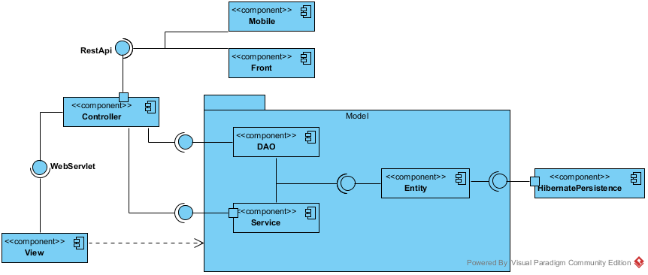

Figure 1: Component Diagram

## Detailed Description Explanation

### Class Diagram

#### Entity Package Class Diagram

Figure 2: Class Diagram

#### Class Diagram Explanation

##### Class 1

Attribute

|  |  |  |  |
| --- | --- | --- | --- |
| **Attribute** | **Type** | **Visibility** | **Description** |
|  |  |  |  |

Method

|  |  |  |  |
| --- | --- | --- | --- |
| **Attribute** | **Type** | **Visibility** | **Description** |
|  |  |  |  |

##### Class 2

Attribute

|  |  |  |  |
| --- | --- | --- | --- |
| **Attribute** | **Type** | **Visibility** | **Description** |
|  |  |  |  |

Method

|  |  |  |  |
| --- | --- | --- | --- |
| **Attribute** | **Type** | **Visibility** | **Description** |
|  |  |  |  |

#### DAO Package Class Diagram

Figure 3: Class Diagram

#### Class Diagram Explanation

##### RepairStatus

Attribute

|  |  |  |  |
| --- | --- | --- | --- |
| **Attribute** | **Type** | **Visibility** | **Description** |
| id | int | private | The id of the status of repair |
| name | String | private | The name of the status of repair |
| description | String | private | The description of the status of repair |

Method

|  |  |  |  |
| --- | --- | --- | --- |
| **Attribute** | **Type** | **Visibility** | **Description** |
| getters | attribute type | public | Get the respective attribute value |
| setters | void | public | Set the respective attribute with the value |

##### RepairDetail

Attribute

|  |  |  |  |
| --- | --- | --- | --- |
| **Attribute** | **Type** | **Visibility** | **Description** |
| id | int | private | The id of the repair detail |
| repairId | int | private | The id of the repair |
| amenityId | int | private | The id of the amenity |

Method

|  |  |  |  |
| --- | --- | --- | --- |
| **Attribute** | **Type** | **Visibility** | **Description** |
| getters | attribute type | public | Get the respective attribute value |
| setters | void | public | Set the respective attribute with the value |

##### Repair

Attribute

|  |  |  |  |
| --- | --- | --- | --- |
| **Attribute** | **Type** | **Visibility** | **Description** |
| id | int | private | The id of the repair |
| contractId | int | private | The id of the repair |
| assignedStaff | String | private | Username of staff who responsibility for this repair request |
| repairStatusId | int | private | The id of the status of repair |
| description | String | private | The description of the repair request |
| createTime | Timestamp | private | Time when customer create this repair request |
| updateTime | Timestamp | private | Time when manger or staff change status |
| assignedTime | Timestamp | private | Time when manager assign to staff |

Method

|  |  |  |  |
| --- | --- | --- | --- |
| **Attribute** | **Type** | **Visibility** | **Description** |
| getters | attribute type | public | Get the respective attribute value |
| setters | void | public | Set the respective attribute with the value |

##### PaymentTerm

Attribute

|  |  |  |  |
| --- | --- | --- | --- |
| **Attribute** | **Type** | **Visibility** | **Description** |
| id | int | private | The id of the payment term |
| name | String | private | The name of the payment term |
| paymentTime | int | private | Number months of the payment |
| description | String | private | The description of payment term |

Method

|  |  |  |  |
| --- | --- | --- | --- |
| **Attribute** | **Type** | **Visibility** | **Description** |
| getters | attribute type | public | Get the respective attribute value |
| setters | void | public | Set the respective attribute with the value |

##### ContractStatus

Attribute

|  |  |  |  |
| --- | --- | --- | --- |
| **Attribute** | **Type** | **Visibility** | **Description** |
| id | int | private | The id of the contract status |
| name | String | private | The name of the contract status |
| description | String | private | The description of the contract status |

Method

|  |  |  |  |
| --- | --- | --- | --- |
| **Attribute** | **Type** | **Visibility** | **Description** |
| getters | attribute type | public | Get the respective attribute value |
| setters | void | public | Set the respective attribute with the value |

##### Contract

Attribute

|  |  |  |  |
| --- | --- | --- | --- |
| **Attribute** | **Type** | **Visibility** | **Description** |
| id | int | private | The id of the contract |
| customerUsername | String | private | Username of customer |
| officeId | int | private | The id of the office |
| startDate | date | private | Date when contract starts |
| endDate | date | private | Date when contract ends |
| paymentFee | int | private | Payment fee for the contract |
| paymentTerm | int | private | Payment term for the contract |
| statusId | int | private | The id of contract status |

Method

|  |  |  |  |
| --- | --- | --- | --- |
| **Attribute** | **Type** | **Visibility** | **Description** |
| getters | attribute type | public | Get the respective attribute value |
| setters | void | public | Set the respective attribute with the value |

##### OfficeStatus

Attribute

|  |  |  |  |
| --- | --- | --- | --- |
| **Attribute** | **Type** | **Visibility** | **Description** |
| id | int | private | The id of the office status |
| name | String | private | The name of the office status |
| description | String | private | The description of the office status |

Method

|  |  |  |  |
| --- | --- | --- | --- |
| **Attribute** | **Type** | **Visibility** | **Description** |
| getters | attribute type | public | Get the respective attribute value |
| setters | void | public | Set the respective attribute with the value |

##### OfficeGroup

Attribute

|  |  |  |  |
| --- | --- | --- | --- |
| **Attribute** | **Type** | **Visibility** | **Description** |
| officeId | int | private | The id of the office |
| officeGroup | int | private | Group of office for searching |

Method

|  |  |  |  |
| --- | --- | --- | --- |
| **Attribute** | **Type** | **Visibility** | **Description** |
| getters | attribute type | public | Get the respective attribute value |
| setters | void | public | Set the respective attribute with the value |

##### PriceTerm

Attribute

|  |  |  |  |
| --- | --- | --- | --- |
| **Attribute** | **Type** | **Visibility** | **Description** |
| id | int | private | The id of the price term |
| name | String | private | The name of the price term |
| description | String | private | The description of the price term |

Method

|  |  |  |  |
| --- | --- | --- | --- |
| **Attribute** | **Type** | **Visibility** | **Description** |
| getters | attribute type | public | Get the respective attribute value |
| setters | void | public | Set the respective attribute with the value |

##### EmailQueue

Attribute

|  |  |  |  |
| --- | --- | --- | --- |
| **Attribute** | **Type** | **Visibility** | **Description** |
| id | int | private | The id of the email queue |
| username | String | private | Username of the customer |
| officeIds | String | private | The id of list office that system suggests to customer |
| createTime | date | private | Time when customer create request |

Method

|  |  |  |  |
| --- | --- | --- | --- |
| **Attribute** | **Type** | **Visibility** | **Description** |
| getters | attribute type | public | Get the respective attribute value |
| setters | void | public | Set the respective attribute with the value |

##### Office

Attribute

|  |  |  |  |
| --- | --- | --- | --- |
| **Attribute** | **Type** | **Visibility** | **Description** |
| id | int | private | The id of the office |
| name | String | private | The name of the office |
| categoryId | int | private | The id of the category |
| statusId | int | private | The id of the status office |
| description | String | private | The description of the office |
| price | long | private | The price of the office |
| priceTerm | int | private | The price term of the office |
| floorNumber | int | private | The number of floor in the office |
| area | double | private | The area of the office |
| imageUrls | String | private | Link of the images of office |
| otherDetail | String | private | Some detail of the office |
| address | String | private | The address of the office |
| latitude | Double | private | Latitude of the office |
| longitude | Double | private | Longitude of the office |
| district | String | private | The district of the office |
| city | String | private | The city of the office |
| parentOfficeId | int | private | The parent office id of the office |
| createDate | Timestamp | private | Date when office create in database |
| viewCount | int | private | Number views when customer see detail of office |

Method

|  |  |  |  |
| --- | --- | --- | --- |
| **Attribute** | **Type** | **Visibility** | **Description** |
| getters | attribute type | public | Get the respective attribute value |
| setters | void | public | Set the respective attribute with the value |

##### Appointment

Attribute

|  |  |  |  |
| --- | --- | --- | --- |
| **Attribute** | **Type** | **Visibility** | **Description** |
| id | int | private | The id of the appointment |
| customerUsername | String | private | The username of customer |
| assignedStaff | String | private | Staff who is responsibility for the appointment |
| officeId | int | private | Office where customer want to make appointment |
| time | Timestamp | private | Time for appointment |
| statusId | int | private | The status of the appointment |
| createTime | Timestamp | private | Time when customer create appointment |
| updateTime | Timestamp | private | Time when manager update the appointment |

Method

|  |  |  |  |
| --- | --- | --- | --- |
| **Attribute** | **Type** | **Visibility** | **Description** |
| getters | attribute type | public | Get the respective attribute value |
| setters | void | public | Set the respective attribute with the value |

##### Account

Attribute

|  |  |  |  |
| --- | --- | --- | --- |
| **Attribute** | **Type** | **Visibility** | **Description** |
| username | String | private | Unique identifier of an account |
| password | String | private | Password for login to system |
| email | String | private | Email of this account |
| roleId | int | private | Role of this account |
| statusId | int | private | Status of this account |

Method

|  |  |  |  |
| --- | --- | --- | --- |
| **Attribute** | **Type** | **Visibility** | **Description** |
| getters | attribute type | public | Get the respective attribute value |
| setters | void | public | Set the respective attribute with the value |

##### AccountStatus

Attribute

|  |  |  |  |
| --- | --- | --- | --- |
| **Attribute** | **Type** | **Visibility** | **Description** |
| id | int | private | The id of an account status |
| name | String | private | The name of this status |
| description | String | private | The description for this status |

Method

|  |  |  |  |
| --- | --- | --- | --- |
| **Attribute** | **Type** | **Visibility** | **Description** |
| getters | attribute type | public | Get the respective attribute value |
| setters | void | public | Set the respective attribute with the value |

##### Role

Attribute

|  |  |  |  |
| --- | --- | --- | --- |
| **Attribute** | **Type** | **Visibility** | **Description** |
| id | int | private | The id of a role |
| roleName | String | private | The name of role |

Method

|  |  |  |  |
| --- | --- | --- | --- |
| **Attribute** | **Type** | **Visibility** | **Description** |
| getters | attribute type | public | Get the respective attribute value |
| setters | void | public | Set the respective attribute with the value |

##### Profile

Attribute

|  |  |  |  |
| --- | --- | --- | --- |
| **Attribute** | **Type** | **Visibility** | **Description** |
| username | String | private | The id of an account |
| title | String | private | Gender of the profile |
| fullName | String | private | Full name of this profile |
| company | String | private | Company of this profile |
| phone | String | private | Phone of this profile |
| address | String | private | Address of this profile |
| birthday | Timestamp | private | Birthday of this profile |

Method

|  |  |  |  |
| --- | --- | --- | --- |
| **Attribute** | **Type** | **Visibility** | **Description** |
| getters | attribute type | public | Get the respective attribute value |
| setters | void | public | Set the respective attribute with the value |

##### AppointmentStatus

Attribute

|  |  |  |  |
| --- | --- | --- | --- |
| **Attribute** | **Type** | **Visibility** | **Description** |
| id | int | private | The id of an appointment status |
| name | String | private | The name of appointment status |
| description | String | private | The description for appointment status |

Method

|  |  |  |  |
| --- | --- | --- | --- |
| **Attribute** | **Type** | **Visibility** | **Description** |
| getters | attribute type | public | Get the respective attribute value |
| setters | void | public | Set the respective attribute with the value |

##### Category

Attribute

|  |  |  |  |
| --- | --- | --- | --- |
| **Attribute** | **Type** | **Visibility** | **Description** |
| id | int | private | The id of category |
| name | String | private | The name of category |
| description | String | private | The description of category |

Method

|  |  |  |  |
| --- | --- | --- | --- |
| **Attribute** | **Type** | **Visibility** | **Description** |
| getters | attribute type | public | Get the respective attribute value |
| setters | void | public | Set the respective attribute with the value |

##### OfficeAmentity

Attribute

|  |  |  |  |
| --- | --- | --- | --- |
| **Attribute** | **Type** | **Visibility** | **Description** |
| id | int | private | The id of office amenity |
| officeId | int | private | The id of office |
| amentityId | int | private | The id of amenity |

Method

|  |  |  |  |
| --- | --- | --- | --- |
| **Attribute** | **Type** | **Visibility** | **Description** |
| getters | attribute type | public | Get the respective attribute value |
| setters | void | public | Set the respective attribute with the value |

##### Rental

Attribute

|  |  |  |  |
| --- | --- | --- | --- |
| **Attribute** | **Type** | **Visibility** | **Description** |
| id | int | private | The id of rental |
| contractId | int | private | The id of contract |
| assignStaff | String | private | Username of staff who responsibility for this rental request |
| statusId | int | private | The status id of this rental request |
| description | String | private | The description of rental |
| createTime | Timestamp | private | Time when customer create this rental request |
| updateTime | Timestamp | private | Time when manger or staff change status |
| assignedTime | Timestamp | private | Time when manager assign to staff |

Method

|  |  |  |  |
| --- | --- | --- | --- |
| **Attribute** | **Type** | **Visibility** | **Description** |
| getters | attribute type | public | Get the respective attribute value |
| setters | void | public | Set the respective attribute with the value |

##### RequestOffice

Attribute

|  |  |  |  |
| --- | --- | --- | --- |
| **Attribute** | **Type** | **Visibility** | **Description** |
| id | int | private | The id of the request office |
| customerUsername | String | private | Username of customer |
| categoryId | int | private | The id of category |
| price | int | private | Price of the office |
| area | int | private | Area of the office |
| district | int | private | District of the office |
| createTime | Timestamp | private | Time when customer create this rental request |
| scheduleDate | Timestamp | private | Date when system check this request |
| OfficeSuggested | String | private | List offices that are suitable with request |

Method

|  |  |  |  |
| --- | --- | --- | --- |
| **Attribute** | **Type** | **Visibility** | **Description** |
| getters | attribute type | public | Get the respective attribute value |
| setters | void | public | Set the respective attribute with the value |

##### RequestAmenity

Attribute

|  |  |  |  |
| --- | --- | --- | --- |
| **Attribute** | **Type** | **Visibility** | **Description** |
| id | int | private | The id of request amenity |
| requestOfficeId | int | private | The id of request office |
| amentityId | int | private | The id of amenity |
|  |  |  |  |

Method

|  |  |  |  |
| --- | --- | --- | --- |
| **Attribute** | **Type** | **Visibility** | **Description** |
| getters | attribute type | public | Get the respective attribute value |
| setters | void | public | Set the respective attribute with the value |

##### Amenity

Attribute

|  |  |  |  |
| --- | --- | --- | --- |
| **Attribute** | **Type** | **Visibility** | **Description** |
| id | int | private | The id of amenity |
| name | String | private | Name of this amenity |
| description | String | private | Description for this amenity |
| weight | int | private | Weight of amenity in one group |
| amenityGroupId | int | private | Group of this amenity |
| priority | int | private | Priority of amenity in one group |

Method

|  |  |  |  |
| --- | --- | --- | --- |
| **Attribute** | **Type** | **Visibility** | **Description** |
| getters | attribute type | public | Get the respective attribute value |
| setters | void | public | Set the respective attribute with the value |

##### AmenityGroup

Attribute

|  |  |  |  |
| --- | --- | --- | --- |
| **Attribute** | **Type** | **Visibility** | **Description** |
| id | int | private | The id of amenity group |
| name | String | private | Name of amenity group |
| description | String | private | Description for amenity group |
|  |  |  |  |

Method

|  |  |  |  |
| --- | --- | --- | --- |
| **Attribute** | **Type** | **Visibility** | **Description** |
| getters | attribute type | public | Get the respective attribute value |
| setters | void | public | Set the respective attribute with the value |

##### RentalStatus

Attribute

|  |  |  |  |
| --- | --- | --- | --- |
| **Attribute** | **Type** | **Visibility** | **Description** |
| id | int | private | The id of the status of rental |
| name | String | private | The name of the status of rental |
| description | String | private | The description of the status of rental |

Method

|  |  |  |  |
| --- | --- | --- | --- |
| **Attribute** | **Type** | **Visibility** | **Description** |
| getters | attribute type | public | Get the respective attribute value |
| setters | void | public | Set the respective attribute with the value |

##### RentalItem

Attribute

|  |  |  |  |
| --- | --- | --- | --- |
| **Attribute** | **Type** | **Visibility** | **Description** |
| id | int | private | The id of rental item |
| name | String | private | Name of the item |
| description | String | private | Description for the item |
| price | double | private | Price of the item |
| quantity | int | private | Quantity of the item |
| imageUrl | String | private | Link image of the item |

Method

|  |  |  |  |
| --- | --- | --- | --- |
| **Attribute** | **Type** | **Visibility** | **Description** |
| getters | attribute type | public | Get the respective attribute value |
| setters | void | public | Set the respective attribute with the value |

##### RentalDetail

Attribute

|  |  |  |  |
| --- | --- | --- | --- |
| **Attribute** | **Type** | **Visibility** | **Description** |
| id | int | private | The id of rental detail |
| rentalItemId | int | private | Item rental for the rental request |
| rentalId | int | private | Id of request rental |
| unitPrice | double | private | Price of one item |
| quantity | int | private | Quantity of rental item for the rental request |

Method

|  |  |  |  |
| --- | --- | --- | --- |
| **Attribute** | **Type** | **Visibility** | **Description** |
| getters | attribute type | public | Get the respective attribute value |
| setters | void | public | Set the respective attribute with the value |

#### Service Package Class Diagram

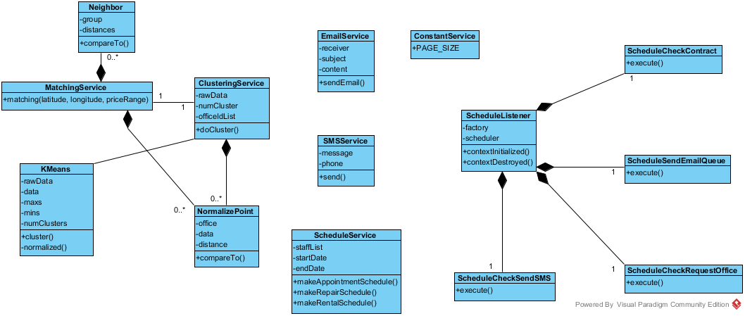

Figure 4: Service Package Class Diagram

#### Class Diagram Explanation

##### EmailService

Attribute

|  |  |  |  |
| --- | --- | --- | --- |
| **Attribute** | **Type** | **Visibility** | **Description** |
| receiver | String | private | The recipient of the email |
| subject | String | private | The subject of the email |
| content | String | private | The content of the email |

Method

|  |  |  |  |
| --- | --- | --- | --- |
| **Attribute** | **Type** | **Visibility** | **Description** |
| sendEmail | boolean | public | Send the email with the subject and content to the receiver |

##### SMSService

Attribute

|  |  |  |  |
| --- | --- | --- | --- |
| **Attribute** | **Type** | **Visibility** | **Description** |
| message | String | private | The SMS message will be sent |
| phone | String | private | The phone number of the recipient |

Method

|  |  |  |  |
| --- | --- | --- | --- |
| **Attribute** | **Type** | **Visibility** | **Description** |
| send() | String | public | Send the SMS message to the recipient. Return “SUCCESS” if sent success, otherwise return the error message form the service provider |

##### ConstantService

Attribute

|  |  |  |  |
| --- | --- | --- | --- |
| **Attribute** | **Type** | **Visibility** | **Description** |
| PAGE_SIZE | int | public | The constant for the page size of the list in admin pages |

##### ScheduleService

Attribute

|  |  |  |  |
| --- | --- | --- | --- |
| **Attribute** | **Type** | **Visibility** | **Description** |
| staffList | List<Staff> | private | The list of all staff for the service |
| startDate | DateTime | private | The start date of the week for the schedule |
| endDate | DateTime | private | The end date of the week for the schedule |

Method

|  |  |  |  |
| --- | --- | --- | --- |
| **Attribute** | **Type** | **Visibility** | **Description** |
| makeAppointmentSchedule() | Map | public | Return the schedule hash map with appointment id and staff username for the unassigned appointment |
| makeRepairSchedule() | Map | public | Return the schedule hash map with repair id and pre-arranged repair for the unassigned repair |
| makeRentalSchedule() | Map | public | Return the schedule hash map with rental id and pre-arranged rental for the unassigned rental |

##### KMeans

Attribute

|  |  |  |  |
| --- | --- | --- | --- |
| **Attribute** | **Type** | **Visibility** | **Description** |
| rawData | double[][] | private | The raw data for k-means algorithm |
| data | double[][] | private | The normalized data for k-means algorithm |
| maxs | double[] | private | The array for max value of each dimension of k-means |
| mins | double[] | private | The array for min value of each dimension of k-means |
| numClusters | int | private | The number of cluster (k) in k-means algorithm |

Method

|  |  |  |  |
| --- | --- | --- | --- |
| **Attribute** | **Type** | **Visibility** | **Description** |
| cluster | double[] | public | Do the k-means algorithm. Return the array of group id for each of input data |
| normalized | double[][] | private | Normalize the raw data |

##### ClusteringService

Attribute

|  |  |  |  |
| --- | --- | --- | --- |
| **Attribute** | **Type** | **Visibility** | **Description** |
| rawData | double[][] | private | The input raw data of all office |
| numCluster | int | private | The calculated k-means number |
| officeIdList | int[] | private | List of all office id |

Method

|  |  |  |  |
| --- | --- | --- | --- |
| **Attribute** | **Type** | **Visibility** | **Description** |
| doCluster | int[] | public | Do the k-means clustering for all office. The result is saved to database also return the array of office group by all office |

##### NormalizePoint

Attribute

|  |  |  |  |
| --- | --- | --- | --- |
| **Attribute** | **Type** | **Visibility** | **Description** |
| office | Office | private | Use to store the office for clustering service |
| data | double[] | private | The normalize data for current office |
| distance | double | private | The distance between the data point and query point in MatchingService |

Method

|  |  |  |  |
| --- | --- | --- | --- |
| **Attribute** | **Type** | **Visibility** | **Description** |
| compareTo() | int | public | Return the compare result of 2 NormalizePoint |

##### MatchingService

Method

|  |  |  |  |
| --- | --- | --- | --- |
| **Attribute** | **Type** | **Visibility** | **Description** |
| matching() | List<Office> | public | Do the matching group for the input office point and the all office data. Return the list of matched office group sort by relevant |

##### Neighbor

Attribute

|  |  |  |  |
| --- | --- | --- | --- |
| **Attribute** | **Type** | **Visibility** | **Description** |
| group | int | private | The index of the office group |
| distances | List<Double> | private | The list of distance of query point and office in group for the KNN matching service |

Method

|  |  |  |  |
| --- | --- | --- | --- |
| **Attribute** | **Type** | **Visibility** | **Description** |
| compareTo() | int | public | Compare distance between query point and two list of data |

##### ScheduleListener

Attribute

|  |  |  |  |
| --- | --- | --- | --- |
| **Attribute** | **Type** | **Visibility** | **Description** |
| factory | SchedulerFactory | private | The factory for initiate the scheduler |
| scheduler | Scheduler | private | The class contain the instance of the scheduler factory |

Method

|  |  |  |  |
| --- | --- | --- | --- |
| **Attribute** | **Type** | **Visibility** | **Description** |
| contextInitialized() | void | public | Override context listener when the app initialized |
| contextDestroyed() | void | public | O Override context listener when the app destroyed |

##### ScheduleCheckContract

Method

|  |  |  |  |
| --- | --- | --- | --- |
| **Attribute** | **Type** | **Visibility** | **Description** |
| execute | void | public | Execute the schedule for check the contract due date. Cancel the contract if the contract at due date |

##### ScheduleCheckRequestOffice

Method

|  |  |  |  |
| --- | --- | --- | --- |
| **Attribute** | **Type** | **Visibility** | **Description** |
| execute | void | public | Execute the schedule for check the Request office. Stored the found office and queue to send an email to customer |

##### ScheduleCheckSendSMS

Method

|  |  |  |  |
| --- | --- | --- | --- |
| **Attribute** | **Type** | **Visibility** | **Description** |
| execute | void | public | Execute the schedule for check the appointment date. Send a SMS to user if the appointment date is near |

##### ScheduleCheckEmailQueue

Method

|  |  |  |  |
| --- | --- | --- | --- |
| **Attribute** | **Type** | **Visibility** | **Description** |
| execute | void | public | Execute the schedule for check the email in queue to send |

#### Controller Package Class Diagram

Figure 5: Class Diagram

#### Class Diagram Explanation

##### Class 1

Attribute

|  |  |  |  |
| --- | --- | --- | --- |
| **Attribute** | **Type** | **Visibility** | **Description** |
|  |  |  |  |

Method

|  |  |  |  |
| --- | --- | --- | --- |
| **Attribute** | **Type** | **Visibility** | **Description** |
|  |  |  |  |

##### Class 2

Attribute

|  |  |  |  |
| --- | --- | --- | --- |
| **Attribute** | **Type** | **Visibility** | **Description** |
|  |  |  |  |

Method

|  |  |  |  |
| --- | --- | --- | --- |
| **Attribute** | **Type** | **Visibility** | **Description** |
|  |  |  |  |

#### View Package Class Diagram

Figure 6: Class Diagram

#### Class Diagram Explanation

##### Class 1

Attribute

|  |  |  |  |
| --- | --- | --- | --- |
| **Attribute** | **Type** | **Visibility** | **Description** |
|  |  |  |  |

Method

|  |  |  |  |
| --- | --- | --- | --- |
| **Attribute** | **Type** | **Visibility** | **Description** |
|  |  |  |  |

##### Class 2

Attribute

|  |  |  |  |
| --- | --- | --- | --- |
| **Attribute** | **Type** | **Visibility** | **Description** |
|  |  |  |  |

Method

|  |  |  |  |
| --- | --- | --- | --- |
| **Attribute** | **Type** | **Visibility** | **Description** |
|  |  |  |  |

#### Front Package Class Diagram

Figure 7: Class Diagram

#### Class Diagram Explanation

##### Class 1

Attribute

|  |  |  |  |
| --- | --- | --- | --- |
| **Attribute** | **Type** | **Visibility** | **Description** |
|  |  |  |  |

Method

|  |  |  |  |
| --- | --- | --- | --- |
| **Attribute** | **Type** | **Visibility** | **Description** |
|  |  |  |  |

##### Class 2

Attribute

|  |  |  |  |
| --- | --- | --- | --- |
| **Attribute** | **Type** | **Visibility** | **Description** |
|  |  |  |  |

Method

|  |  |  |  |
| --- | --- | --- | --- |
| **Attribute** | **Type** | **Visibility** | **Description** |
|  |  |  |  |

#### Mobile Package Class Diagram

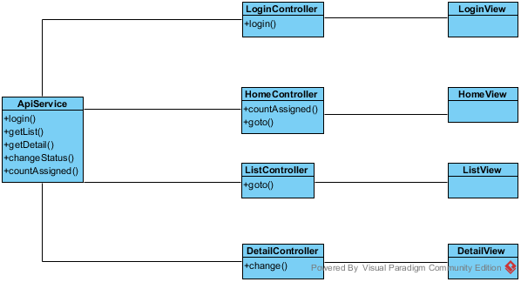

Figure 8: Mobile Package Class Diagram

#### Class Diagram Explanation

##### ApiService

Method

|  |  |  |  |
| --- | --- | --- | --- |
| **Attribute** | **Type** | **Visibility** | **Description** |
| login() | function | public | Call the login api and return the result. |
| getList() | function | public | Call the getList api to return the list of job for current staff (appointment/rental/repair) |
| getDetail() | function | public | Call the getDetail api to return the detail of current job |
| countAssigned() | function | public | Call the countAssigned api to return the number of assigned for current job |
| changeStatus() | function | public | Call the changeStatus api to change the status of current job |

##### LoginController

Attribute

|  |  |  |  |
| --- | --- | --- | --- |
| **Attribute** | **Type** | **Visibility** | **Description** |
| username | string | private | The inputted username |
| password | string | private | The inputted password |

Method

|  |  |  |  |
| --- | --- | --- | --- |
| **Attribute** | **Type** | **Visibility** | **Description** |
| login() | function | private | Call the login function of ApiService |

##### LoginView

This is the presentation view of LoginController

##### HomeController

Attribute

|  |  |  |  |
| --- | --- | --- | --- |
| **Attribute** | **Type** | **Visibility** | **Description** |
| title | string | private | The title of the job (appointment/rental/repair) |
| badge | Array | private | The array of number of assigned job |

Method

|  |  |  |  |
| --- | --- | --- | --- |
| **Attribute** | **Type** | **Visibility** | **Description** |
| countAssigned() | function | private | Call the countAssigned function of ApiService to get the job number |
| goto() | function | private | Go to the list page of the job |

##### HomeView

This is the presentation view of HomeController

##### ListController

Attribute

|  |  |  |  |
| --- | --- | --- | --- |
| **Attribute** | **Type** | **Visibility** | **Description** |
| title | string | private | The title of the job (appointment/rental/repair) |
| data | Array | private | The array of the detail of job |

Method

|  |  |  |  |
| --- | --- | --- | --- |
| **Attribute** | **Type** | **Visibility** | **Description** |
| goto() | function | private | Go to the detail page of the job |

##### ListView

This is the presentation view of ListController

##### DetailController

Attribute

|  |  |  |  |
| --- | --- | --- | --- |
| **Attribute** | **Type** | **Visibility** | **Description** |
| title | string | private | The title of the job (appointment/rental/repair) |
| data | object | private | The detail of job |

Method

|  |  |  |  |
| --- | --- | --- | --- |
| **Attribute** | **Type** | **Visibility** | **Description** |
| change() | function | private | Call the api to change the status of the job |

##### DetailView

This is the presentation view of DetailController

### Interaction Diagram

#### <Staff> Create office

**Summary:** This diagram used to describe the process of staff create an office

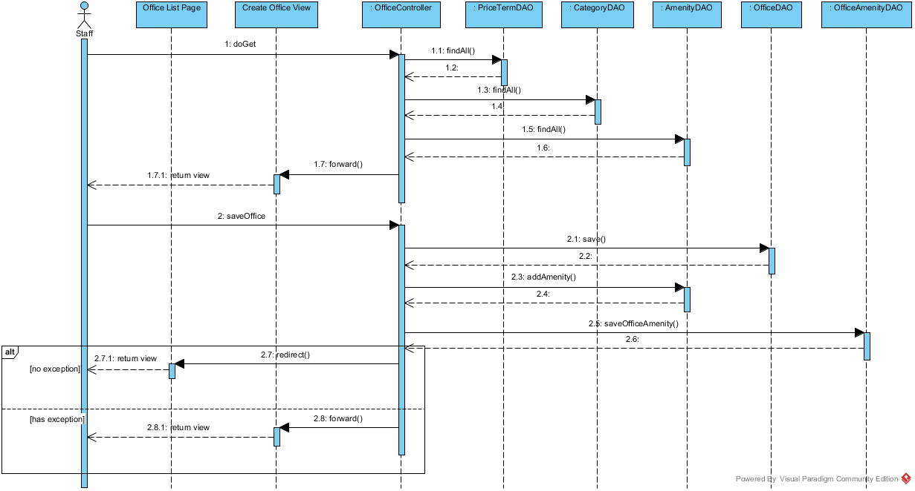

Figure 10: Create office Sequence Diagram

#### <Manager> Create contract

**Summary:** This diagram used to describe the process of create new contract.

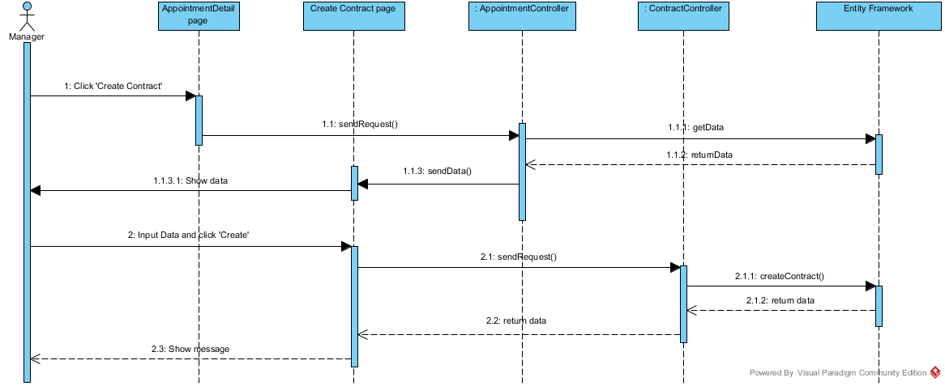

Figure 11: Create Contract Sequence Diagram

#### <Manager> Assign Appointment

**Summary:** This diagram used to describe the process of manager assign an appointment to a staff

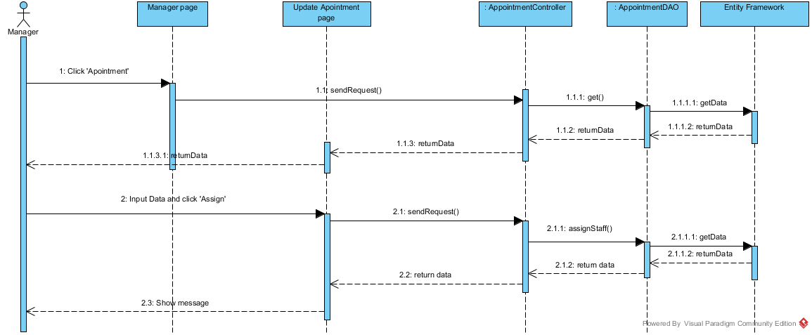

Figure 12: Assign Appointment Sequence Diagram

#### <Manager> Update Appointment

**Summary:** This diagram used to describe the process of manager update an appointment detail

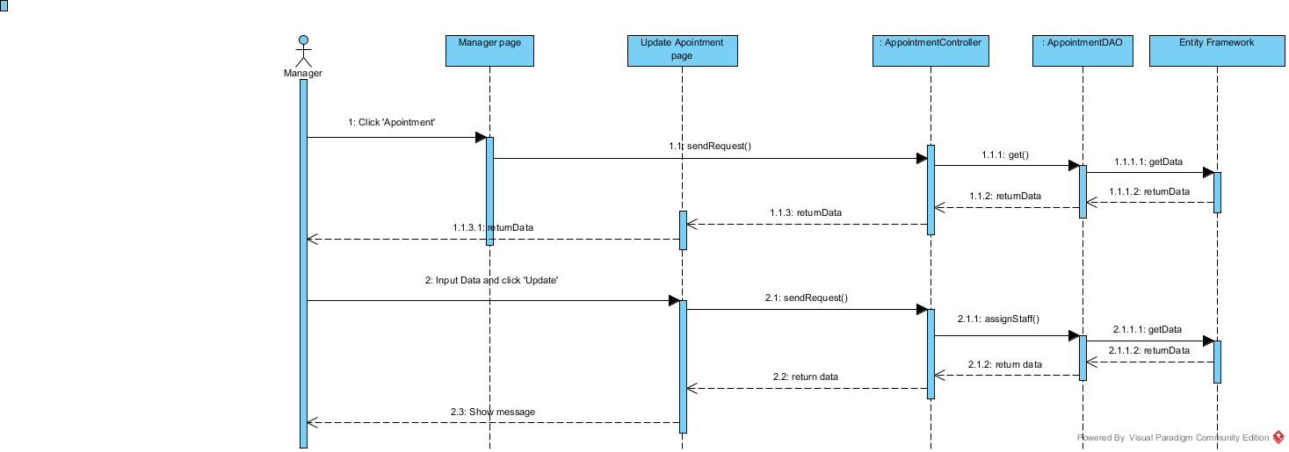

Figure 13: Update Appointment Sequence Diagram

#### <Customer> Get Office List

**Summary:** This diagram used to describe the process of customer request repair office

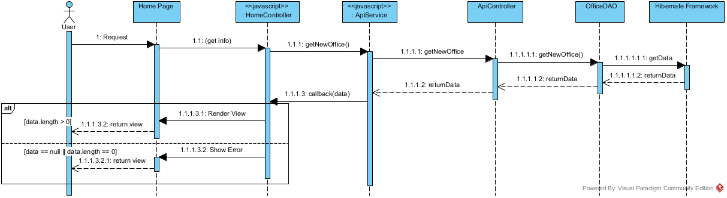

Figure 14: Get office list Sequence Diagram

#### <Customer> Request Appointment

**Summary:** This diagram used to describe the process of customer request an appointment.

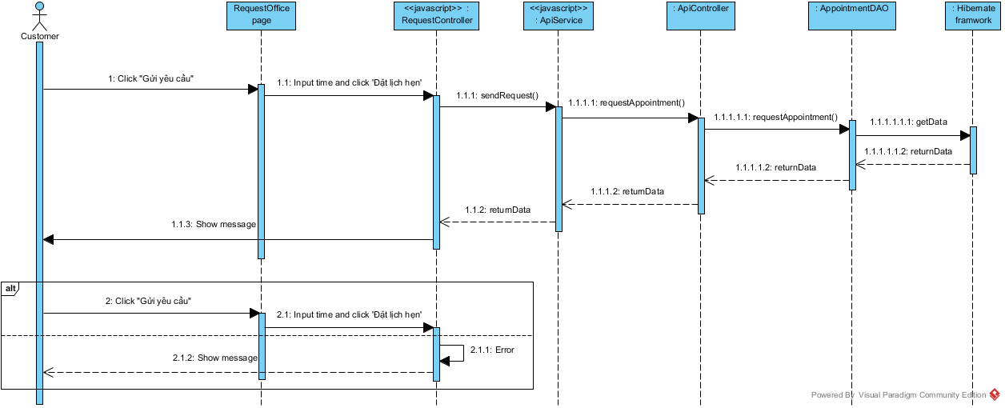

Figure 15: Request Appointment Sequence Diagram

#### <Customer> Request Repair

**Summary:** This diagram used to describe the process of customer request repair office

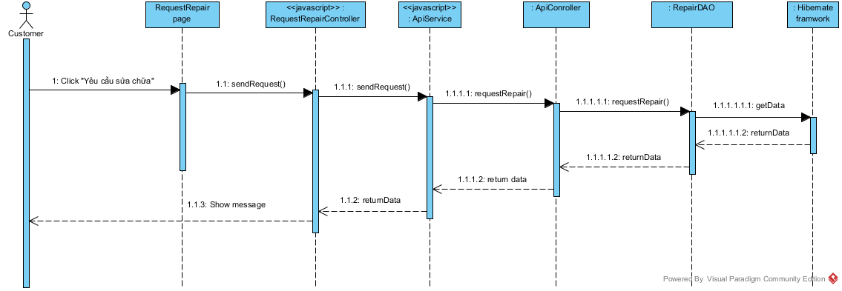

Figure 16: Request Repair Sequence Diagram

## Database Design

### Logical Diagram

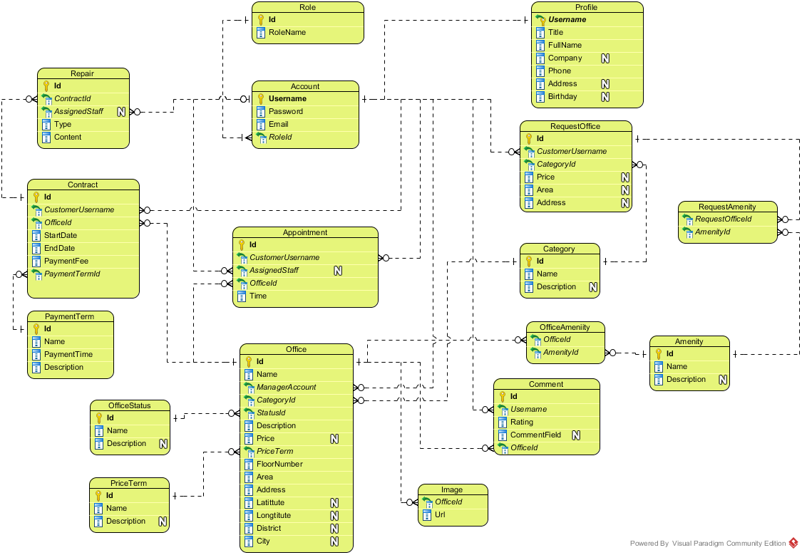

**Figure 17: Logical Database Diagram**

### Data Dictionary

|  |  |
| --- | --- |
| **Entity Data dictionary: describe content of all entities** | |
| **Entity Name** | **Description** |
| Account | Describe account of user of system. |
| Staff | Describe account type staff |
| Admin | Describe account type admin |
| Manager | Describe account type manager |
| Customer | Describe account type customer |
| Profile | Describe the contact information for customer |
| Office | Describe information of the office |
| Category | Describe the category of the office |
| Amenity | Describe the amenities of the office |
| Image | List of images of the office |
| Appointment | Describe the information of the appointment of customer for the office |
| Contract | Describe the information of contract between customer and office |
| Request Office | Describe the stored office request of customer |
| Repair | Describe the repair request for each contract |
| Rental | Describe the rental request for contract |
| Rental Item | Describe the rental items which available for rental request |
| Account | Describe account of user of system. |
| Staff | Describe account type staff |
| Admin | Describe account type admin |
| Manager | Describe account type manager |
| Customer | Describe account type customer |

Table 1: Entity Data Dictionary